Lab 12 Managing Internet Explorer Connections And Security
This lab contains the following exercises and activities:
- Exercise 12-1: Connecting to the Internet
- Exercise 12-2: Internet Security
- Exercise 12-3: Maintaining Internet Explorer
- Exercise 12-4: Using Group Policy to Configure Internet Explorer
- Lab Review Questions
Scenario
At Contoso, Ltd., like many companies, Microsoft Internet Explorer is used every day by many employees. Employees need access to internal intranet sites, as well as to sites outside the company network.
As a technical support agent at Contoso, you are frequently contacted concerning Internet connections that are not working or Web sites that are not behaving as expected. Often these problems can be fixed through the Internet Explorer interface.
After completing this lab, you will be able to:
- Configure Internet connections.
- Secure Internet Explorer and configure its security zones.
- Perform common maintenance tasks in Internet Explorer.
Before You Begin
Establish your network connection using the following steps.
- Log on as local Administrator.
- From the Start menu right-click on My Computer and select Properties
- From the Computer Name tab click on Change.
- In the Computer Name Change dialog box erase .local from the Domain box.
- Click OK
- In the Computer Name Change dialog box in User name type Administrator and in the Password box type none.
- Click OK
- After a few seconds you will be welcomed to the Contoso domain click OK.
- Click on the dialog box that tells you that you must restart your computer.
- Click OK in the Systems Properties dialog box.
- Click Yes in the Systems Setting Change dialog box, you computer will shut down and restart.
- Log on as local administrator.
- From the start menu select Control Panel
- Select Security Center
- Open the Windows Firewall and make sure that it is Off.
- Close all windows.
There are no prerequisites for this lab.
This lab uses the variable xx to refer to your number so that your computer name is referred to as Computerxx and your student identity as Studentxx. You are asked to pair with another student in this lab. Your partner's number is referred to as yy.
Exercise 12-1: Connecting To The Internet
There are many different ways to configure Internet connectivity, depending on what your purposes are and how your Internet service provider (ISP) provides Internet access.
Connecting with a Broadband Connection
An employee needs help configuring his home Internet connection. He sub-scribes to a cable Internet provider and has his network card connected to the cable modem.
NOTE because you already have an Internet connection, the following steps will not create a new Internet connection. This exercise will, however, demonstrate the steps for doing so.
- Log on with your local Administrator account (the password is P@sswOrd).
- From the Start menu, select Control Panel.
- In Control Panel (in Category view), click Network And Internet Connections.
- In the Network And Internet Connections window, click Network Connections.
- In the Network Connections window, in the Network Tasks pane, click Create A New Connection.
- In the New Connection Wizard, on the Welcome page, click Next.
- On the Network Connection Type page, ensure Connect To The Internet is selected and then click Next.
- On the Getting Ready page, select Setup My Connection Manually and then click Next.
- On the Internet Connection page, select Connect Using A Broadband Connection That Is Always On and then click Next.
- On the Completing The New Connection Wizard page, click Finish.

Connecting Through a Proxy Server
For greater security and control over content, Contoso has installed a proxy server for Internet access. You need to configure Internet Explorer to use the new proxy server to connect to the Internet. However, you do not want local addresses to be served through the proxy server.
- From the Start menu, select Internet Explorer.
- In Internet Explorer, from the Tools menu, select Internet Options.
- In the Internet Options dialog box, on the Connections tab, click LAN Settings.
- In the Local Area Network (LAN) Settings dialog box, select the Use A Proxy Server For Your LAN (These Settings Will Not Apply To Dial-Up Or VPN Connections) check box.
- In the Address text box, type http://proxy.example.contoso.com.
- In the Port text box, type 80.
- Select the Bypass Proxy For Local Addresses check box. The correct configuration is shown in the following figure.
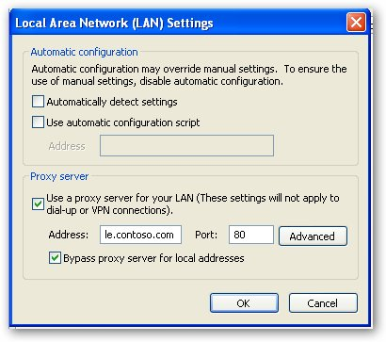
- Click Cancel.
Important You clicked Cancel because there is no proxy server on the network named proxy.example.contoso.com. If you were configuring a proxy server in reality, you would click OK and check connectivity.
- Leave the Internet Options dialog box open.

Connecting Through a Proxy Server Using WPAD
Contoso has implemented the Web Proxy Auto-Discovery (WPAD) protocol on top of the DNS servers so that Internet Explorer can be dynamically assigned a proxy server. Also, a configuration script file has been created so that configuration changes can be made centrally in the script file, and the Internet Explorer clients will update automatically. You need to configure Internet Explorer to use these resources.
- In the Internet Options dialog, on the Connections tab, click LAN Settings.
- In the Local Area Network (LAN) Settings dialog box, select the Automatically Detect Settings check box.
- Select the Use Automatic Configuration Script check box.
- In the Address text box, type http://proxy.example.contoso.com/ proxy.pac. Click Cancel.
Important You clicked Cancel because this task was for practice only; there are no such resources on the network.
- Leave the Internet Options dialog box open.
Exercise 12-2: Internet Security
Internet Content Zones and Security Settings
You frequently visit the Contoso Web site, which uses pop-ups as part of its design. However, Internet Explorer's pop-up blocker, which was installed as part of Service Pack 3, is blocking the pop-ups and making it difficult to use the site. You need to add the site to a Web content zone that allows pop-ups by default.
Also, you want the Internet Web content zone to be more strict in its security. Specifically, you want the user to be prompted before ActiveX controls are run because there has been a rash of Trojan horses spread through ActiveX controls.
- In the Internet Options dialog box, on the Security tab, ensure that Internet is selected as shown in the figure below, and then click Default all zones to default level.
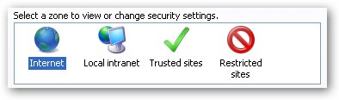
Question 1: Fill in the table below with the default security levels for each Web content zone?
Internet
Local Internet
Trusted
Restricted

- Select Trusted Sites, and then click Custom Level.
- In the Security Settings dialog box, scroll until you find the entry Use Pop-Up Blocker.
Question 2: What is the default setting in the Trusted Sites Web content zone for the pop-up Blocker?
- Click OK.
- In the Internent Options dialog box, click Sites.
- In the Trusted Sites dialog box, in the Add This Web Site To The Zone text box, type https://www.contoso.com and then click Add. Click Close

Question 3: What does the s stand for in the protocol?
- In the Internet Options dialog box, select Internet and then click Custom Level.
- In the Security Settings dialog box, under Run ActiveX Controls And Plug-Ins, select Prompt, as shown in the following figure. Click OK.
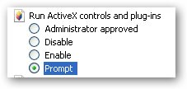
- In the Warning message box, click Yes to change the settings for the zone.
- Leave the Internet Options dialog box open.

Advanced Security Settings
A user accesses encrypted information from the Internet and does not want the decrypted information to be stored on the computer locally because it is a multi-user computer.
- In the Internet Options dialog box, click the Advanced tab.
- On the Advanced tab, in the Settings list box under Security, select the Do Not Save Encrypted Pages To Disk check box, as shown in the following figure.
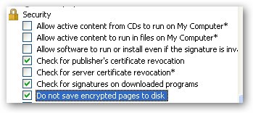
- Leave the Internet Options dialog box open.

Exercise 12-3: Maintaining Internet Explorer
Setting Cookie Options to Secure Privacy
Some cookies report information to parties unknown to the user. To prevent cookies from reporting information to a third party, you need to adjust the cookie options in Internet Explorer.
The following steps will create a low tolerance for cookie adoption.
- In the Internet Options dialog box, on the Privacy tab, in the Settings section, move the slider to High.
Question 4: What two sets of cookies does this setting block?
- Click Advanced.
Question 5: Although it is currently inactive, what option do you have concerning session cookies? (Session cookies are cached only while a user is connected to the issuing server and are deleted when the user closes the session.)
- Click OK.
- Leave the Internet Options dialog box open.

Deleting Temporary Internet Files Manually
A user complains of slow Internet Explorer performance. He mentions that he has some offline Web pages that he no longer needs. You need to empty the temporary Internet files so that there is room in the cache for new Web pages.
NOTE The following steps manually delete temporary Internet files with the purpose of demonstrating where the files are kept and what type of files are stored. Normally, you would delete the files by clicking Delete Files on the General tab of the Internet Options dialog box.
- In the Internet Options dialog box, on the General tab, in the Browsing History section, click Settings.
- In the Settings dialog box, click View Files.

Question 6: What is the path to Temporary Internet Files folder?
- In the Temporary Internet Files folder, from the Edit menu, select Select All. Press the DELETE key.
- In the Warning message box, click Yes to delete the files.
- Close the Temporary Internet Files folder.
- In the Settings dialog box, click Cancel.
- Leave the Internet Options dialog box open.

Automatically Deleting Temporary Internet Files on Exiting Internet Explorer
A user who visits proprietary company Web sites wants to make sure that no temporary files from those sites remain on his computer when he exits Internet Explorer.
- In the Internet Options dialog box, click the Advanced tab.
- In the Settings list box, under Security, select the Empty Temporary Internet Files Folder When Browser Is Closed check box.
- Leave the Internet Options dialog box open.

Deleting Cookies
There have been reports that a popular Web site might have been saving malicious cookies on client computers. The cookies have been removed from the Web site, but your computer might be infected. You need to delete all your cookies to be safe.
- In the Internet Options dialog box, on the General tab, in the Browsing History Section answer the following question
Question 7: Summarize what happens if you select Delete browsing history on exit.
- Leave the Internet Options dialog box open.

Changing the Caching Settings
A user wants to be assured that each time he visits a page it is up to date and does not rely on cached data. Also, the user stores a lot of offline Web sites, and you need to double the size of the temporary Internet files cache on his computer.
- In the Internet Options dialog box, on the General tab, in the Browser History section, click Settings.
- In the Settings dialog box, under Check for newer versions of stored pages, select Every time I visit the web page..
- In the Temporary Internet Files and History Settings dialog box, in the Disk Space To Use spin box, type 500 The correct settings are shown in the following figure.
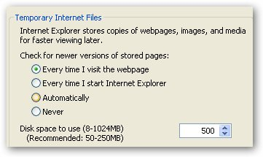
- Click Cancel.
- In the Internet Options dialog box, click Cancel.
- Leave Internet Explorer open.

Managing Add-Ons
Internet Explorer add-ons are powerful tools, but they are easy for third parties to abuse. Users often allow add-ons to be installed without understanding the consequences. One such user has had his computer hijacked by an add-on. You intend to uninstall the add-on completely with a spyware removal utility, but for now you need to tell him how to disable the add-on.
- From the Tools menu, select Manage Add-Ons.
- In the Manage Add-Ons dialog box, select Windows Messenger.
Note: The Windows Messenger add-on is not a legitimate Internet Explorer add-on and is just used here as a convenient example of how to disable an add-on.
- In the Settings section, right-click and select Disable.
- In the Manage Add-Ons dialog box, click Close.
- Close Internet Explorer.

Exercise 12-4: Using Group Policy to Configure Internet Explorer
Management at Contoso has decided that all users are to have the same home page initially. Also, the title bar of Internet Explorer is to be customized to include the company name.
The following steps will implement these changes using Group Policy.
- From the Start menu, select Run.
- In the Run dialog box, in the Open text box, type gpedit.msc and press ENTER.
- In the Group Policy console, under User Configuration, expand Windows Settings, Internet Explorer Maintenance, and select URLs, as shown in the following figure.
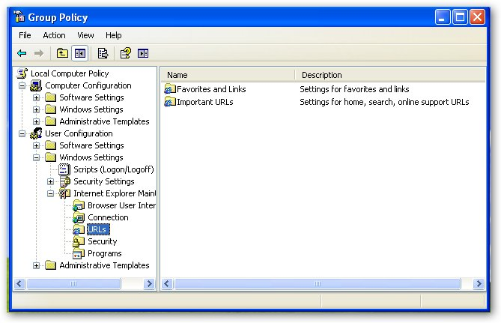
- In the details pane, in the Name column, double-click Important URLs.
- In the Important URLs dialog box, select the Customize Home Page URL check box.
- In the Home Page URL text box, type http://www.elgin.edu. Click OK
- In the Group Policy console, select Browser User Interface.
- In the details pane, in the Name column, double-click Browser Title.
- In the Browser Title dialog box, select the Customize Title Bars check box.
- In the Title Bar Text text box, type Contoso. Click OK.
- Close the Group Policy console.
- Open Internet Explorer.
- Answer yes to any dialog box that appears.

Question 8: What does the title bar read in Internet Explorer?
Lab Review Questions
1. What protocol that can be administered by either a DHCP or a DNS server provides a way for clients to receive the address of a proxy server?
2. List the four Web content zones in order of the least secure to the most secure.
3. What is the name of the small files that Web servers can store on your computer to record information, and what are the two types?
4. A user has his computer configured to download certain Web pages while he is online so that they will be available while he is offline. However, when he signs off Internet Explorer and starts it again, the files are not available. What setting on the Advanced tab of the Internet Options dialog box could cause this?
5. A user had a hard drive that was too full. She upgraded the hard drive to a larger size, and she says that Internet Explorer is now faster. Why would this be?

